**EU Declaration of Conformity**

PRODUCT TYPE: **Safety Shoes & Boots**

**BRAND:** WARRIOR

MANUFACTURER:

Liberty Shoes Ltd

Liberty Complex, 17th Milestone

G.T. Karnal Road, Gharaunda, Dist Karnal

Haryana, India 132001

**This declaration of conformity is issued under the sole responsibility of Liberty Shoes Ltd**

**PRODUCT ID: 7198-01, 7198-02, 7198-127, 7198-159, 7198-18, 7198-51, 7198-93**

PRODUCT IMAGE/S:

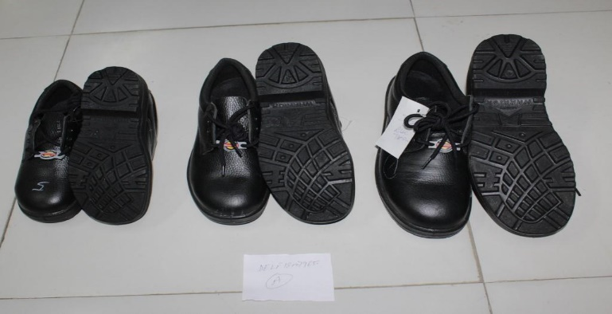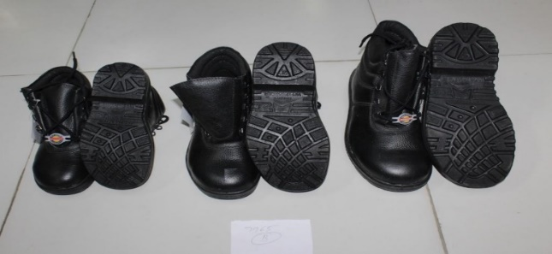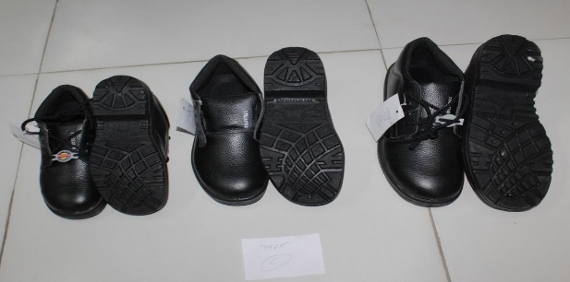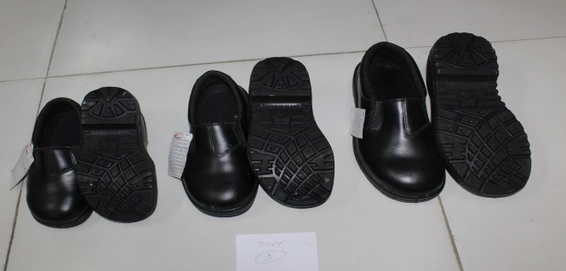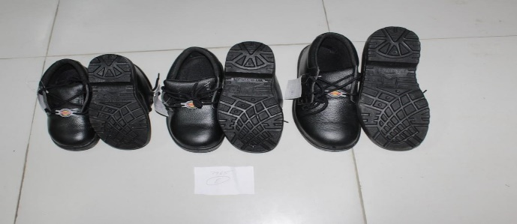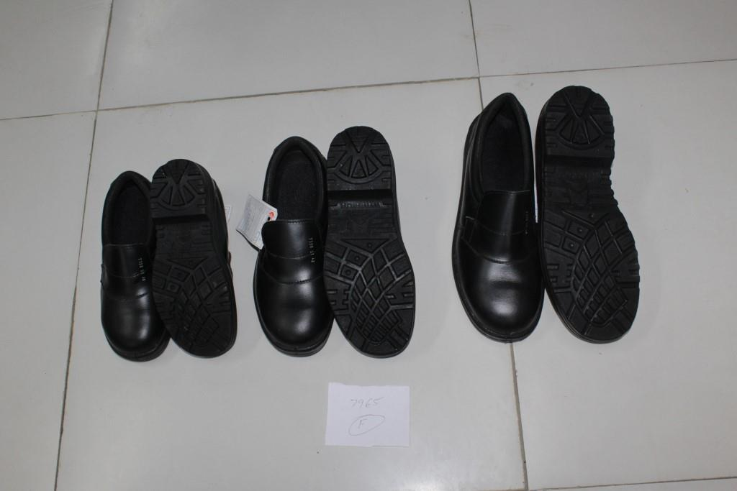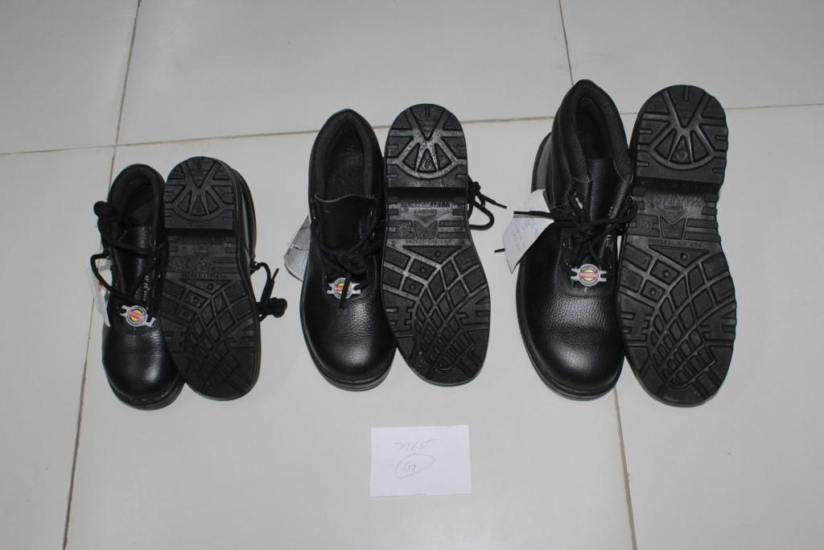

7198-01 7198-02 7198-127 7198-159 7198-18 7198-51 7198-93

The above product is in conformity with the regulation (EU) 2016/425 and is identical to the PPE which is subject of EU certificate…………………………. issued by:

ITS Testing Services UK Ltd

Centre Court, Meridian Business Park,

Leicester, LE19 1WD,

United Kingdom

NB 0362

Relevant Harmonized Standards / Technical Specifications used to which conformity is declared:

EN ISO 20345: 2011

The PPE is subject to the conformity assessment procedure to conformity to type based on internal production control plus supervised products checks at random intervals in accordance with Module C2 of the regulation 2016/425 under surveillance of the notified body: - ITS Testing Services UK Ltd

Centre Court, Meridian Business Park, Leicester, LE19 1WD, United Kingdom

NB 0362

Signed for on behalf of…………….

Date:Sep 29, 2018

Name:**Mr. S.S. Lahiri**

Position: Vice President

Signature: